Lab 4

Question 1

- Employees whose commission is more than 0.25

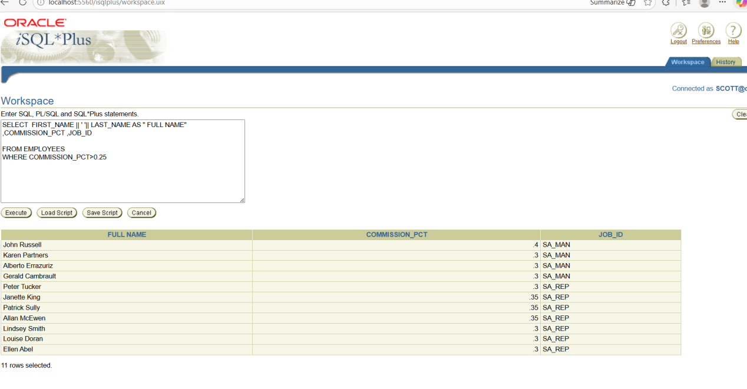

- Employees whose salary is between 5000 and 10000

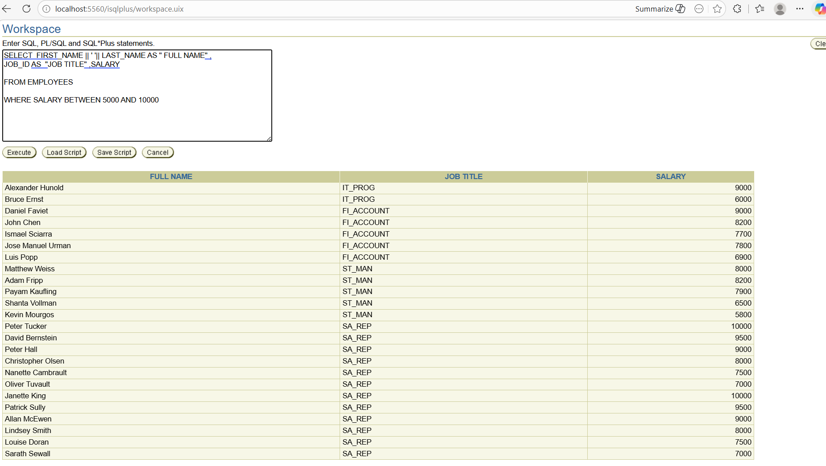

- Employees whose salary is NOT between 5000 and 10000

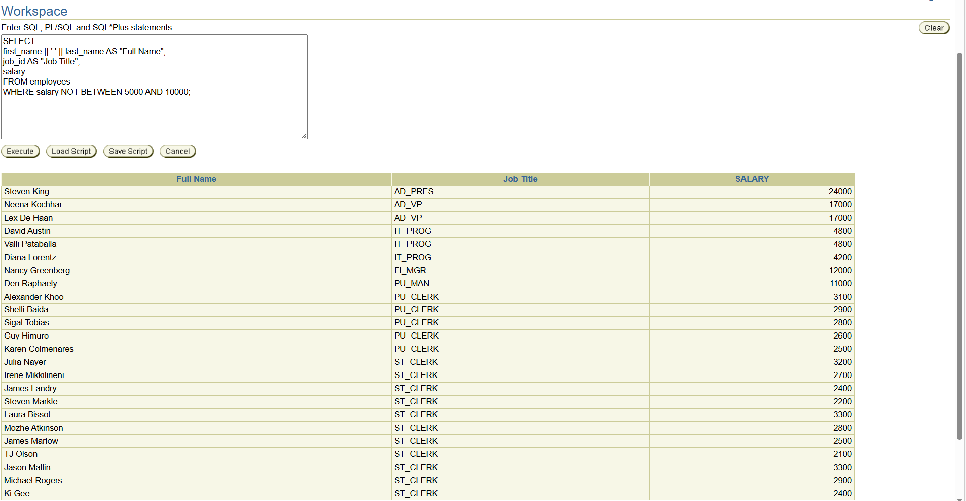

- Difference between Query 2 and Query 3

Query 2
SELECT first_name || ' ' || last_name AS "Full Name",
job_id AS "Job Title",
salary
FROM employees
WHERE salary BETWEEN 5000 AND 10000;

Explanation:
- BETWEEN 5000 AND 10000 selects employees whose salary is within this range.
- It includes both boundary values (5000 and 10000).
- So only employees earning ≥ 5000 and ≤ 10000 will appear.
Example salaries shown:
5000
6200
8500
10000

Query 3
SELECT first_name || ' ' || last_name AS "Full Name",
job_id AS "Job Title",
salary
FROM employees
WHERE salary NOT BETWEEN 5000 AND 10000;

Explanation:
- NOT BETWEEN selects employees whose salary is outside this range.
- It shows employees earning less than 5000 or greater than 10000.
Example salaries shown:
3000
4500
11000
15000

- Display full name, job title and hire date for specific employees

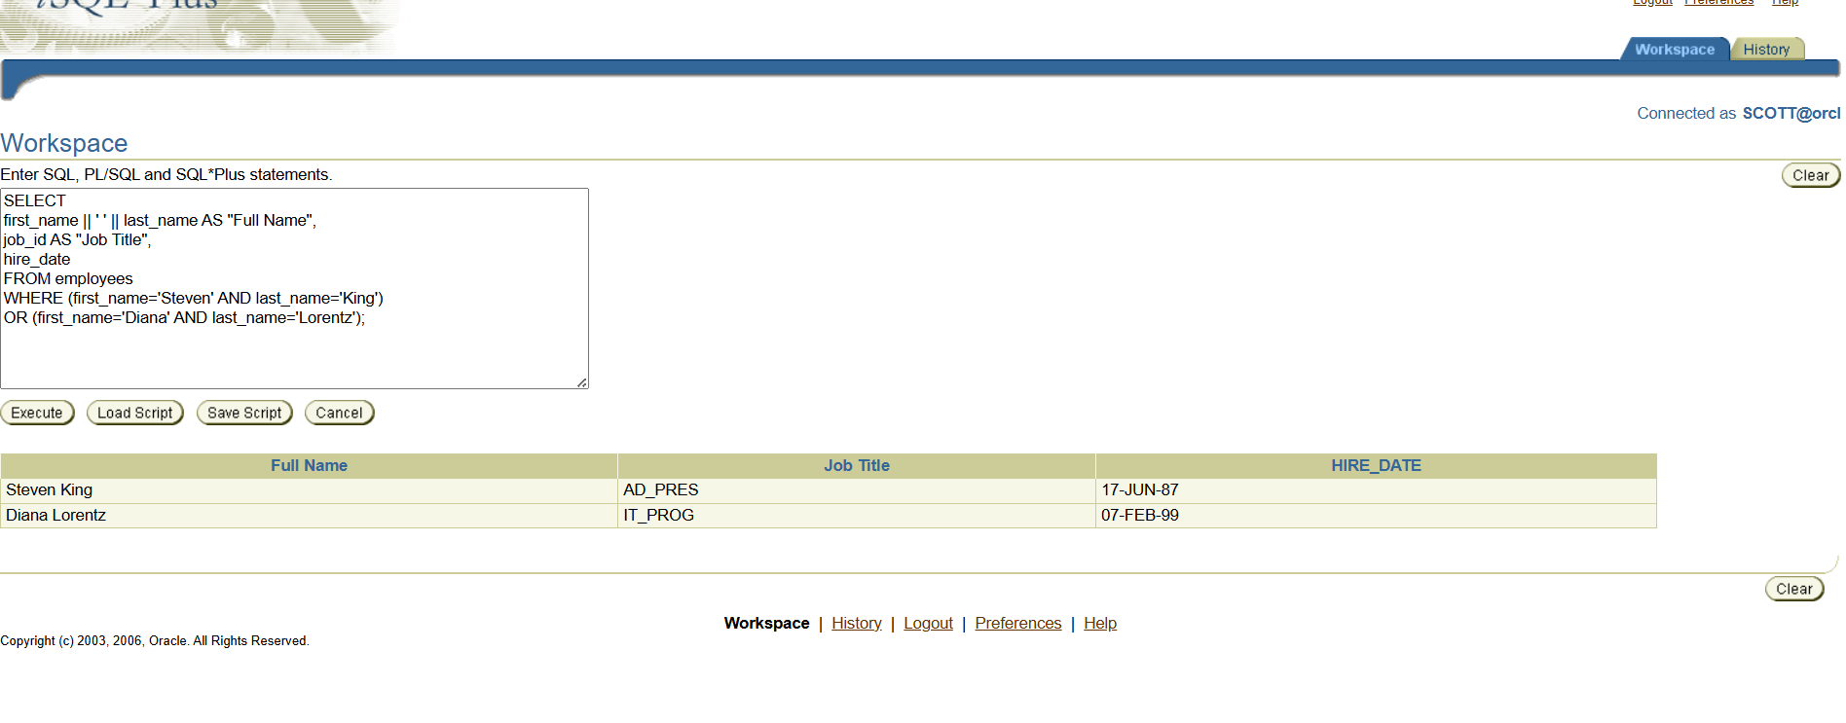

- Display address details of offices in Canada and USA

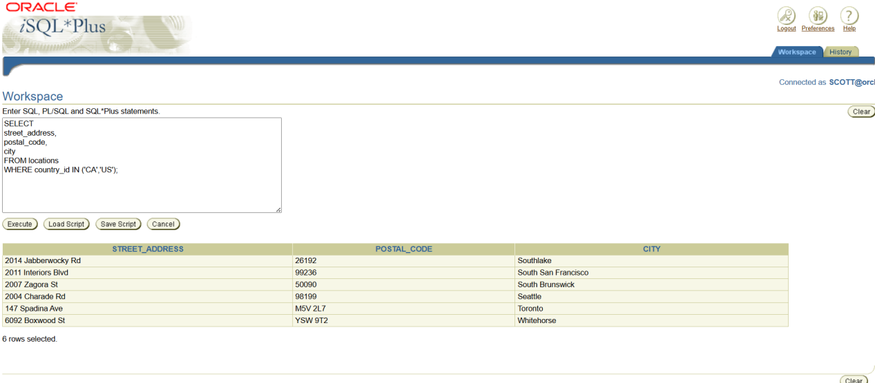

- SYSDATE and DUAL

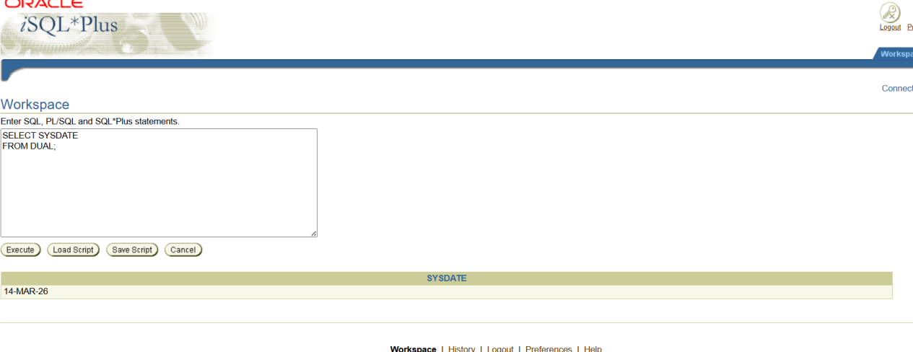

SYSDATE
- Returns the current system date and time of the Oracle server.
Example :
14-MAR-2026

DUAL
- A dummy table in Oracle.
- Contains only one row and one column.
- Used when selecting system values or functions.
Example:
SELECT 5+5 FROM DUAL;

